What relevance does Paula Scher's work have to contemporary practices within the graphic design industry?

Paula Scher is a contemporary graphic designer based in New York. I decided to focus my essay on her practice as she has a very contemporary approach to her work, in which every so often she produces work for free, promoting a liberal ethos within the graphic design community, much like that of Stefan Sagmeisters. Thus, juxtaposing the traditional capitalist function of Graphic Designers. This act has not only resulted in her achieving many awards for her work, such as the AIGA in 2001[1] and the [Type Directors Club Medal in 2006[2],](https://www.tdc.org/medalists/) in which she was the first woman to receive the prize, but it also increased her importance within the design industry as she was able to explore new techniques of her craft and stay relevant within the pop culture. Scher has designed identity and branding systems for a wide range of clients including Citibank, Microsoft, Bloomberg, Shake Shack, the High Line and Tiffany & Co[3]. Within this essay I will discuss what relevance Paula Scher’s work has to contemporary practices within her discipline area.

Paula Scher was born in 1948 in Virginia and studied illustration at the Tyler School of Art before fulfilling her dream of moving to New York City with her portfolio in 1970[4], where she received her first job working in the advertisement and promotion department designing small space ads for the Columbia and Epic labels at CBS Records in 1972 (see fig 1 as example). Three years later she had designed 25 covers, gaining design experience and was hired back to CBS Records as East Coast Art Director where she was responsible for around 150 record covers a year.[5] During this time a female Art Director was unheard of, and Scher addressed this issue within a documentary series on Netflix, “Abstract” recalling to

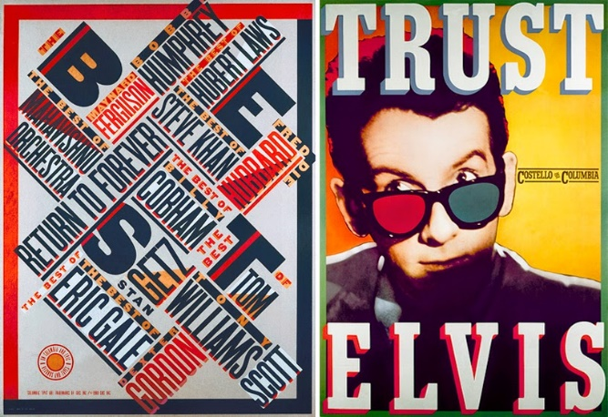Figure 1, Paula Scher, *The Best of Jazz* poster for CBS Records, 1979[6]

the 70s when all women were in organizational roles, agents or reps, ‘I would sit there and think ‘oh my god what are they gonna do with me, what am I gonna do with them.’’[7] Surprisingly, Scher still experiences sexism, continuing to say, ‘If I am sitting with a new client, I can see in the first glance that he’s wondering why he’s got this old lady.’[8] This was the beginning of Schers feministic approach to challenging the 60% to 40% male to female ratio, of professionals within the design world. For example, in 2008, Scher offered Jessica Walsh[9] a three-month internship, working alongside her in Pentagram. During this time Scher recorded advice she had given to Walsh, and other young female designers who were starting off in the male dominated design world:

there’s an advantage that we all have as designers is that we make this tangible thing, that people can ultimately learn about and make a valued judgement about and that is your ticket to actually being able to succeed and get ahead, the problem that is cultural is the fear of expressing it. The notion that you’re not going to be listened to which is true, the idea that if you’re working or competing with a man in a given situation that he is likely to get a different type of attention than what you’re getting… but the advantage is, is that you are still making this tangible thing and the tangible thing can sometimes speak for itself… an advantage that all people are relatively equal.[10]

After a year of working alone, Scher discovered that as a woman working alone in business she wasn’t likely to get large scale projects and that the work she was currently receiving would probably be all she would continue to get.[11] However, in 1991, one of Scher’s friends Woody Pirtle approached her and asked her to join Pentagram, one of the largest and most successful graphic design agency in the world. Scher discussed in an interview with Designboom, that she ‘knew it was an amazing opportunity’ and that she ‘would have never been able to work on the broad diverse types of projects I have been fortunate enough to work on, without the reputation and structure of Pentagram behind it.’[12] Paula Scher was the first female to join the 15 male member graphic design firm.[13]

When Scher joined the Pentagram design firm, it was the start of her influence upon both the design world and New York City. For example one of Schers most successful design was in 1994 when George Wolff had asked Scher to rebrand The Public theatre logo[14] seen in fig 2. Before this the theatre was

Figure 2 Paula Scher, *The* *Public Theatre Identity*, 1994

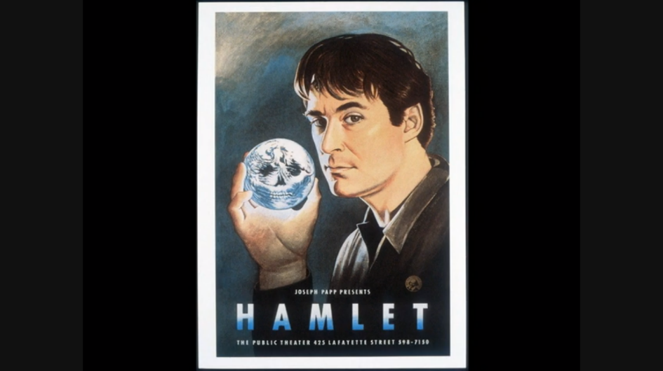having an identity issue, some called it The Public theatre, The Joseph Pump Public theatre, Shakespeare in central park and nothing felt as though it was one unit. Wolff had taken over as director and he wanted to unify the Public’s identity, making it urban and loud and a place that was inclusive to everyone, a complete juxtaposition of the previous posters, seen in fig 3. Scher responded with a design solution, in

Figure 3, Paul Davis, *Joseph Papp Presents Hamlet, The Public Theatre,* 1975

which she used American Wood type in different weights, thus representing the population of New York City from the largest, to the skinniest and ensuring that all of New York felt included within this design. As a result, not only did Scher respond to the needs of her client in which The Public theatre wanted something which represented their mission of providing accessible and innovative performances, but she also fulfilled the subconscious needs of their audience. By using this font type, she was able to connect an audience of a higher socioeconomic background, to those of a lower, as the graphic language reflects street typography, in an almost graffiti-like juxtaposition. Furthermore, the Public theatre asked Pentagram to create posters in 1995 for their production of Savion Glover’s Bring in ‘Da Noise, Bring in ‘Da Funk. Scher responded by creating a series of posters seen in Fig 4, using the same American Wood 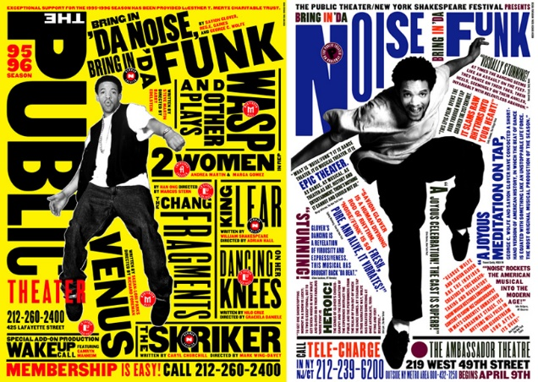type font that was used for The Publics identity[15]. By ensuring that the majority of the posters were

Figure 4, Paula Scher, *Savion Glover’s Bring in ‘Da Noise, Bring in ‘Da Funk*, The Public Theatre poster, 1995

covered in font it created a visual urban noise, a typographical tap-dance, representing what the production was about, taking what was seen on stage and putting it on paper, creating direct audience engagement through this narrative. Moreover, for the first time ever advertisements for The Public theatre were being displayed all around New York City, from Times Square, at the Lincoln Tunnel and most of all, beneath the theatre’s audiences’ feet on the sidewalk. As a result, not only was the advertisements so successful in that the production received four Tony Awards and two Drama Desk Awards in 1996[16], but Scher’s use of maximum typography and minimum imagery became the house layout of New York, from magazine layouts to advertising for other shows, everyone began imitating it, signalling a paradigm shift of a new moment for not only the public theatre but the whole style of theatre advertising. Scher finally began to realise that she was no longer just creating posters or advertisements, but she was creating identities.

As Scher influence continued to spread within New York City, through her work in Pentagram designing for the New York City Ballet and The High Line, Scher removed herself from designing for the web and solely focused on environmental design, designing for the physical world, creating design for humans by humans and making the point to younger designers that design does in fact exist beyond screens that can still impact life. As a result of her relentless work and reinvention of graphic design Scher was named the Public Design Commission of the City of New York in 2006[17]. In 2012, following the horrific aftermath of Hurricane Sandy, Scher was hired to create an emotional sign system for the Rockaway’s beaches. While the boardwalks, which were the heart and soul of the community, were destroyed, what the neighbourhood still had was the 14 miles of beach, and each part of the beach looked unique from every place that you entered it. As each view of the beach was different Scher created these large standing posters with photographs that would help orientate people once they reached the beach, helping to emotionally reconnect the community whilst functioning as directional signage. When the project was 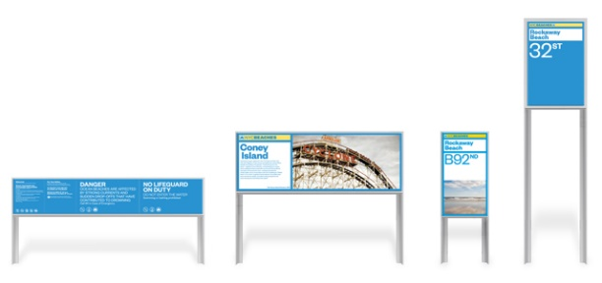revealed five months later (Fig 5.), the community responded with such pride for the signs that the city

Figure 5, Paula Scher, *New York City Beaches,* 2013

Council made postcards,[18] based on the design of the signage for every town, so that they could each have their own picture of their own beach. Scher had not only accomplished the brief of bringing the community back together set out by the city council, but she had also given the communities their own logos, their own icons, creating a sense of identity. This began to influence the design community as designers such as Stefan Sagmeister realised that good design needed to take human behaviour into account.[19]

Paula Schers four decades of working relentlessly to reinvent the graphic design industry from both a creative point of view, and her constant challenge of the male to female ratio within the industry is something that I, as a young female graphic designer admire and aspire to. Her dedication to design and typography lies not just in her craft but in spirit, her work is an extension of her world view, an extension of her ethics and aesthetics and her refusal to accept what’s placed in front of her, from previous designers. Her bold work and frankness grounds us, pulls us back from a self-important design ether and reminds us of the difference between a career and life. Her solutions to problems seem obvious but only in hindsight, they help to reset and show us new ways of thinking, reminding us that our purpose here isn’t about us, that we as graphic designers are just a filter that if done right help others to get through their lives a little easier, that is why Paula Scher is relevant within the graphic design industry.

Bibliography

Books

Sagmeister, S., Heller, S., Nettle, D. and Spector, N. (2008). *Things I have learned in my life so far*. New York: Abrams.

Scher, P. (2002). *Make it bigger*. 1st ed. New York: Princeton Architectural Press

Pentagram (1993). *The Compendium*. London: Phiadon Press Limited.

Adolf Loss (1998). *Ornament and Crime*. Austria: Ariadne Press.

Yelavich, S. (2004). *Profile: Pentagram Design*. London: Phaidon.

Hirasuna, D (2006). *Pentagram Papers, Volume 36*. California: Chronicle Books.

Scher, P (1992). *The Graphic Design Portfolio: How to Make a Good One*. Watson-Guptill.

Journals

Walters, J.L. (2010). Reputations: Paula Scher. *Eye Magazine*. Autumn 2010 (Autumn)

Volland, J.M. (2013). NYC Beaches Wayfinding and Signage. *S.E.G.D*. 07

Websites

AIGA. (2001). *Paula Scher.* Available: https://www.aiga.org/medalist-paulascher. Last accessed 19th December 2018.

tdc.. (2006). *TDC Medal Winners.* Available: https://www.tdc.org/medalists/. Last accessed 19th December 2018.

Pentagram. (2018). *Paula Scher Portfolio.* Available: https://www.pentagram.com/about/paula-scher. Last accessed 28th December 2018.

Nonko E. (April 11th 2017). *INTERVIEW: Paula Scher on designing the brands of New York’s most beloved institutions.* Available: https://www.6sqft.com/interview-paula-scher-on-designing-the-brands-of-new-yorks-most-beloved-institutions/. Last accessed 23rd December 2018.

Playbill. (2018). *Savion Glover.* Available: http://www.playbill.com/person/savion-glover-vault-0000005012. Last accessed 5th December 2018.

Semi Permanent. (2015). *Paula Scher.* Available: https://www.semipermanent.com/profiles/paula-scher. Last accessed 5th December 2018.

Bourton, L. (2017). *One Step Ahead: we meet Paula Scher, the trailblazing Pentagram Partner.* Available: https://www.itsnicethat.com/features/paula-scher-graphic-design-151117. Last accessed 5th December 2018.

Rodd, S. (2014). *Font of Youth: Jessica Walsh, Graphic Design’s ‘It’ Girl.* Available: http://observer.com/2014/04/jessica-walsh-graphic-designer-profile/. Last accessed 5th December 2018.

Siang, T. (2018). *Bad Design vs. Good Design: 5 Examples We can Learn From.* Available: https://www.interaction-design.org/literature/article/bad-design-vs-good-design-5-examples-we-can-learn-frombad-design-vs-good-design-5-examples-we-can-learn-from-130706. Last accessed 5th December 2018.

Videos

ATypl. (2017). *Keynote: Why I love designing for Public places - Paula Scher - ATypI 2017.* Available: https://www.youtube.com/watch?v=g8GwN0sI5Hs. Last accessed 21st December 2018.

Netflix. (2017). *Abstract The Art Of Design.* Available: https://www.netflix.com/title/80057883. Last accessed 20th December 2018.

Blue Deer Design. (2018). *Women in design & how to get to the top.*Available: https://www.youtube.com/c/bluedeerdesign. Last accessed 30th December 2018.

Ted Taks. (2008). *Great design is serious, not solemn-Paula Scher.* Available: https://www.ted.com/talks/paula_scher_gets_serious/up-next. Last accessed 5th December 2018.

1. AIGA. (2001). *Paula Scher.* Available: https://www.aiga.org/medalist-paulascher. Last accessed 19th November 2018.
2. tdc.. (2006). *TDC Medal Winners.* Available: https://www.tdc.org/medalists/. Last accessed 19th November 2018.
3. Pentagram. (2018). *Paula Scher Portfolio.* Available: https://www.pentagram.com/about/paula-scher. Last accessed 28th November 2018.
4. ATypl. (2017). *Keynote: Why I love designing for Public places - Paula Scher - ATypI 2017.* Available: https://www.youtube.com/watch?v=g8GwN0sI5Hs. Last accessed 21st November 2018.
5. including Ted Nugent Free-For-All, and Boston’s Boston which were influenced by contemporary culture such as Zig-Zag rolling papers, Zap Comix and underground newspapers and magazines.
6. The Best of Jazz poster for CBS Records, Paula Scher 1979. The poster shows influences such as Dada in the mixing of different typefaces, Bauhaus from the structuring of type and sans-serif type and the colours shows influence of Russian Constructivism. The Swiss Design principles Scher was taught at the design school can also be seen in the grid from she has placed the type in. However, during an interview with Designboom, 2013 Scher discussed how many of these grid like formats have been influenced by her New York City surroundings, looking like a map of central New York. It was the beginning of a radical shift in her work in which the typography began to take the forefront of her images and the illustration began to take to the background, which would begin to influence many of her graphic design predecessors, such as Jessica Walsh.
7. Netflix. (2017). *Abstract The Art Of Design.* Available: https://www.netflix.com/title/80057883. Last accessed 20th December 2018.
8. Nonko E. (April 11th 2017). *INTERVIEW: Paula Scher on designing the brands of New York’s most beloved institutions.* Available: https://www.6sqft.com/interview-paula-scher-on-designing-the-brands-of-new-yorks-most-beloved-institutions/. Last accessed 23rd December 2018.
9. At the age of 25, became partner of Sagmiester and Walsh design company, 2012
10. Blue Deer Design. (2018). *Women in design & how to get to the top.*Available: https://www.youtube.com/c/bluedeerdesign. Last accessed 30th December 2018.
11. Scher, P. (2002). *Make it bigger*. 1st ed. New York: Princeton Architectural Press. P.10-15
12. Walters, J.L. (2010). Reputations: Paula Scher. *Eye Magazine*. Autumn 2010 (Autumn),
13. Pentagram (1993). *The Compendium*. London: Phiadon Press Limited. 
14. Scher, P. (2008). *Great design is serious, not solemn.* Available: https://www.ted.com/talks/paula_scher_gets_serious/up-next. Last accessed 5th December 2018.
15. Scher, P. (2002). *Make it bigger*. 1st ed. New York: Princeton Architectural Press.
16. Playbill. (2018). *Savion Glover.* Available: http://www.playbill.com/person/savion-glover-vault-0000005012. Last accessed 5th December 2018.
17. Netflix. (2017). *Abstract The Art Of Design.* Available: https://www.netflix.com/title/80057883. Last accessed 20th December 2018.
18. Volland, J.M. (2013). NYC Beaches Wayfinding and Signage. *S.E.G.D*. 07
19. Design is ‘something that causes delight, kind of a positive functional surprise, embedded within an emotional uplifting feeling. Something that makes you feel, respects you as a human, as a person who uses it, and brightens your day. It should do it time and again without taking too much attention. Sometimes good design is very utilitarian, sometimes more flamboyant and artistic, but all in all its about causing an emotional reaction that is either on the more cerebral side, kind of this feeling of delight or surprise over an objects function and beauty or sometimes just the beauty’ (Sagmeister. S. (2008). *Things I have learned in my life so far*. New York: Abrams) and that is what Paula Scher achieves time and time again.